Why Hamilton won’t survive the zombie apocalypse  Hamilton 3rd least likely Canadian city to survive zombie apocalypse   | Bessie the airport cow gone, getting makeover  Cows out for a 'routine refreshing' at auto body shop  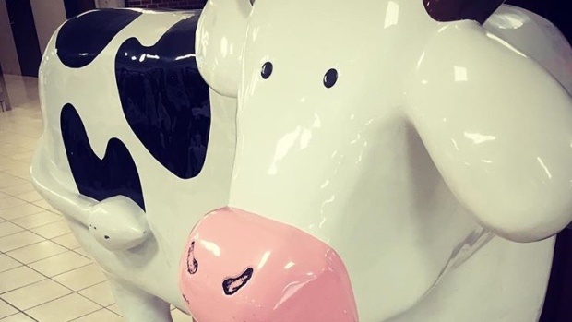
Danes match 300-year-old poop with bishop who made it  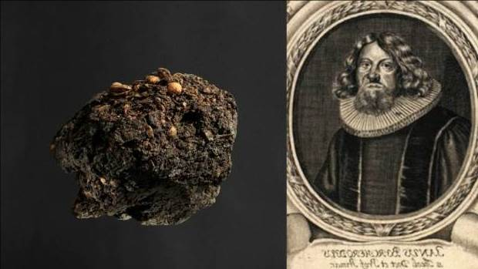 | Disabled rooster loves his new wheelchair  Therapy bird Louise keeps defying the odds and helping at-risk children  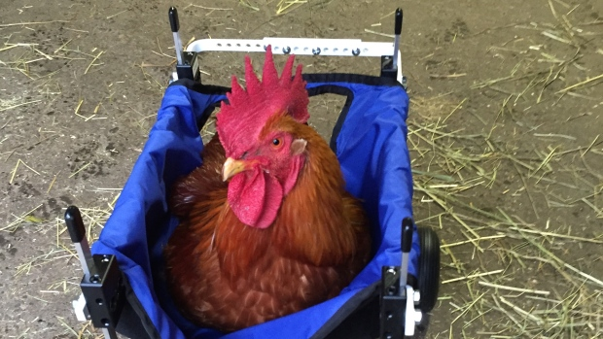
'I love digging': 89-year-old man digs his own grave  'The grandchildren will know that their grandfather dug his own grave with his own backhoe'  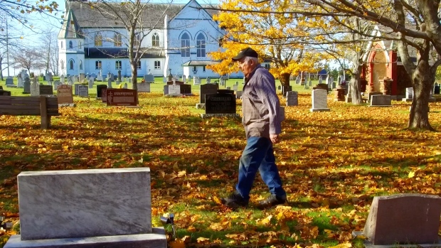 | Psychologists say they can inoculate people against fake news  
Hamilton first Canadian city to host Romantic Comedy convention   | 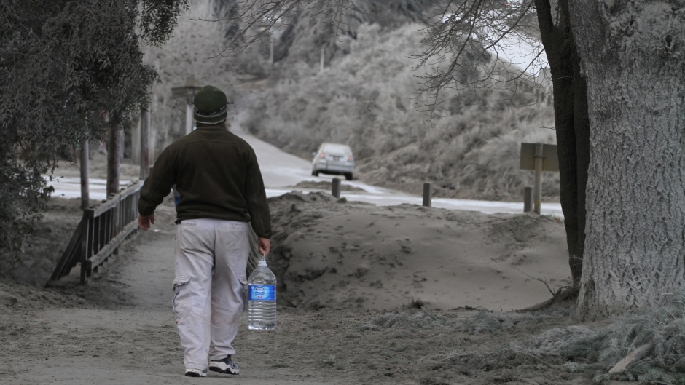  Canadian making thousands of dollars smuggling water into the U.S.
New app called MeatMe allows strangers to sell meat and poultry   | Ontario Minister of Agriculture caught saying, 'I hate eggplant, I wish we'd wipe them out'  

